|  |  |
| --- | --- |
| Mt data  MATLAB Exercise to Explore Neural Data from Area MT | Singh, Jaspreet |

Step 1

**Figure 1.** *Data was collected from the MT area of a monkey animal subject while the monkey was shown a dot moving on a screen. Data was collected from 2 neurons which were tuned for right and left direction. This data was fit with a Weibull function and plotted above as a Psychometric curve. There are 6 coherences (4,8,16,32,64), which can be seen as the blue points on the curve. At each coherence, you can find the proportion of correct responses were increasing coherence of stimulus. This data then shows the proportion of trials where the monkey was correct, meaning, they identified the direction of the stimulus. Thus, the x axis corresponds to coherence level and the y-axis corresponds to the percent correct. Alpha was about 12 and beta around 3.*

***Figure 2.*** *Figure 2**shows the ROC curve analysis for both neurons with each line showing a different coherence. The higher coherence hugs the corner of the graph while lower ones show a more linear relationship and are near the diagonal. The left tuned neuron is the null while right tuned neuron represents the preferred distribution. Criterion ranges from 0 to 100 so the percentage of firing rates surpassing this criterion for the leftward tuned neuron against those for the rightward tuned neuron completed across six distinct coherence levels. The ROC curve's sharpness gradually diminishes, transitioning towards a more linear trajectory as coherence decreases****.***

**Figure 3.** *The figure above shows a neurometric curve for the monkey. made by fitting a Weibull function to the area under each ROC curve plotted against their respective coherence levels. The Weibull function has an alpha value of approximately 16, and a beta value of approximately 1. A neurometric curve was constructed using the firing rate data from the two neurons, shown in Fig 3. Data shown is from the same 100 random trials and was fitted with a Weibull curve, also shown on a logarithmic x-axis for comparison to the psychometric curve. It can be seen that the neurometric curve is not as steep in its increase as the psychometric curve in Fig 1.A*lpha (Threshold): 0.15591 *and* Beta (Sensitivity to Coherence): 1.2026

**Figure 4.** *The ROC shows the analysis performed on the left preferring and right preferring neurons at each of the 6 coherences specified earlier (4,8,16,32,64),. The higher coherences are located near the corners of the graphs while lower coherences align nearest the diagonal of the graph showing a more linear relationship.*

Step 3

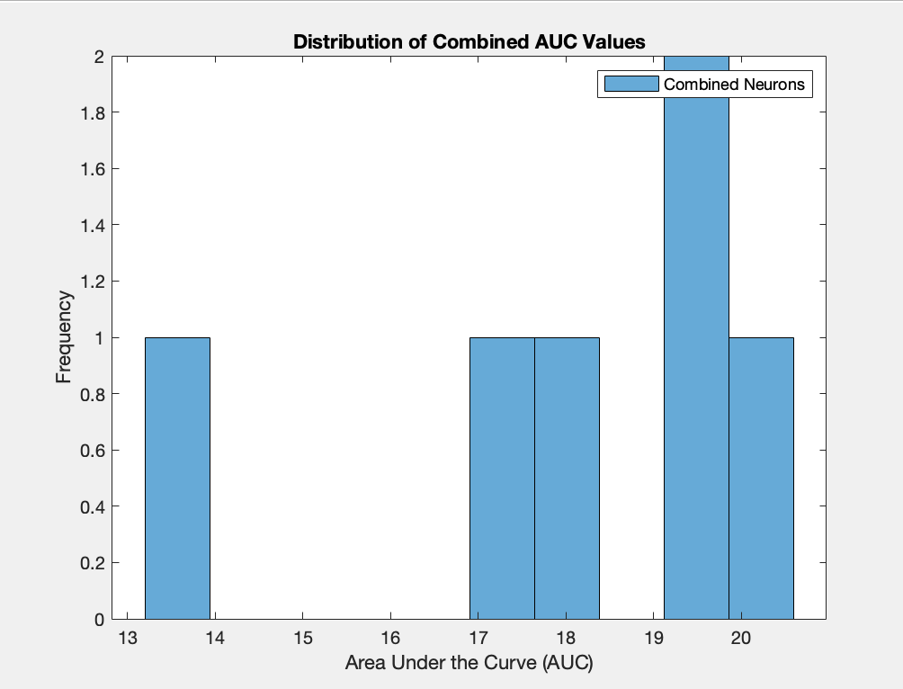

***Figure 5.*** *The figure above shows the Area Under the Curve (AUC) plotted against the frequency of the choice probability values. The histogram is an average of the left and right preferring neurons for the 12 choice probability values determined from the ROC curves in Fig 4. 5 bins were used, with the mean of the distribution falling in the range of .68 to .78. The reported Choice Probability Neuron 1: 0.79761 and Choice Probability Neuron 2: 0.67248.*

Step 4:

*This data analysis is intriguing as it may suggest the presence of an internal bias within the monkey, which closely linked to its own decision-making processes. The choice probabilities of each animal subject lean towards the left. Data analysis performed earlier, from both behavioral and neural data, indicates that perhaps certain neurons are more strongly associated with a specific decision, thereby influencing the overall choice probabilities. It is conceivable that the animal's decision-making process is subject to various factors like attention, distraction, external cues, internal cues, and many other unknown factors. Due to known and unknown factors, sensitivity of individual neurons may manifest differently like in previous literature which shows that animals displayed substantial differences in the decision-making process. In this data analysis, comparing the psychometric curve and the neuromeric curve reveals a increase in coherence, around 10%, which might mean that there is a behavioral inclination beyond the observed neuronal activity, leading to the firing of MT neurons. This would then indicative of an "internal bias" towards the left in the animal's decision-making tendencies. Additionally, the reported choice probability for the left of neuron was reported as .68 to while the choice probability for the right was .78.*